**1.Make Folder for the Project e.g. Pioneer_Control**

**2.Copy all files from this folder to Pioneer_Control**

Path for files-

C:\Program Files\CoppeliaRobotics\CoppeliaSimEdu\programming\legacyRemoteApi\remoteApiBindings\python\python

**3.Copy this file into Pioneer_Control (It has files for MacOs and Ubuntu) select according to OS.**

Path for file-

Windows

C:\Program Files\CoppeliaRobotics\CoppeliaSimEdu\programming\legacyRemoteApi\remoteApiBindings\lib\lib\Windows

**4.Open CoppeliaSim. Save First Scene eg. First_test in the folder Pioneer_Control.**

**5. Add child lua script to the any object in the scene. Eg. To the Floor.**

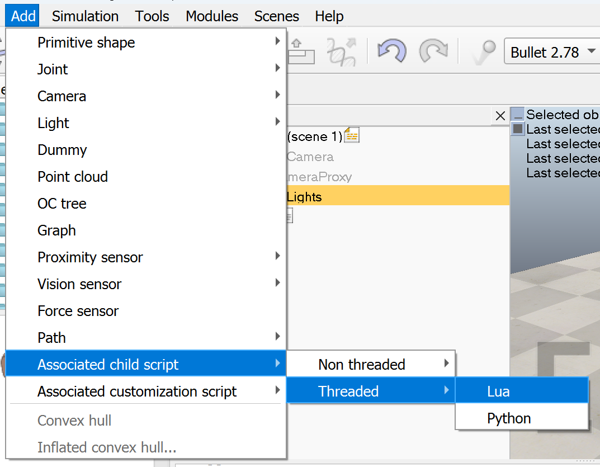

**6.Open that script and paste following for the connection.**

simRemoteApi.start(19999)

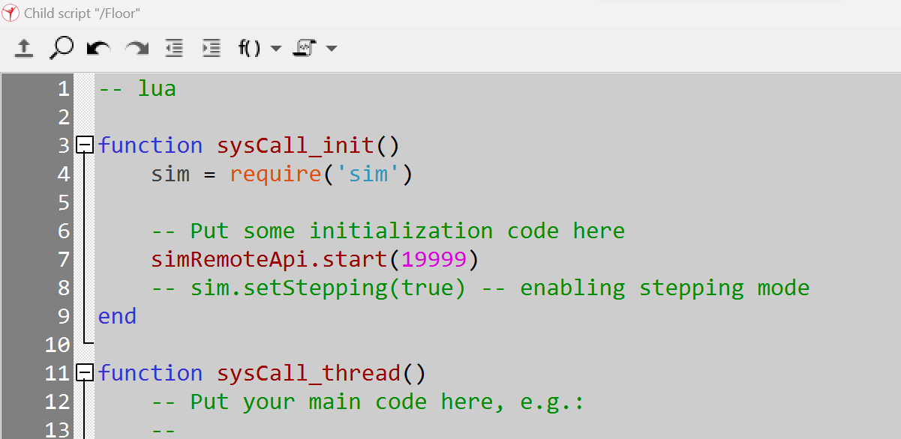

**7. Write Code in python (eg. First_test_code) and save it in the same folder (eg. Pioneer_Control).**

Following code provides connection between python and CoppeliaSim

sim.simxStart('127.0.0.1', 19999, True, True, 5000, 5)

Complete code-

import sim

import sys

print("Program Started")

sim.simxFinish(-1)

clientID = sim.simxStart('127.0.0.1', 19999, True, True, 5000, 5)

if(clientID != -1):

print('Connected Successfully.')

else:

sys.exit('Failed To connect.')

**8.Run the Simulation in the CoppeliaSim**

**9.Run the Python script**

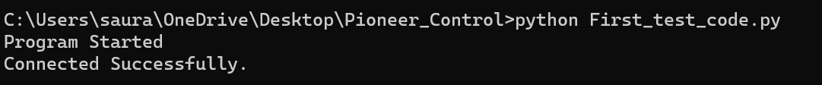

Example to Run basic code and control Pioneer 3DX in the CoppeliaSim using python.

10.Example script to run the Pioneer robot.

I have added scene “Pioneer_control” and the script “Control_robot.py” for your reference.

Before running this script Disable the original Pioneer script in the CoppeliaSim

Code-

import sim

import time

import sys

print("Program Started")

sim.simxFinish(-1) #CLose the previous connection

clientID = sim.simxStart('127.0.0.1', 19999, True, True, 5000, 5) # Establish the connection

if(clientID != -1):

print('Connected Successfully.')

else:

sys.exit('Failed To connect.')

time.sleep(1)

#Get the object handle for the motors

error_code, left_motor_handle = sim.simxGetObjectHandle(clientID, '/PioneerP3DX/leftMotor', sim.simx_opmode_oneshot_wait)

error_code, right_motor_handle = sim.simxGetObjectHandle(clientID, '/PioneerP3DX/rightMotor', sim.simx_opmode_oneshot_wait)

#Give the commands to the robot about velocity

error_code = sim.simxSetJointTargetVelocity(clientID, left_motor_handle, 0.4, sim.simx_opmode_oneshot_wait)

error_code = sim.simxSetJointTargetVelocity(clientID, right_motor_handle, 1, sim.simx_opmode_oneshot_wait)

Script explanation

Import Sim

Get object handle eg. right motor  


Set velocity

Documentation Link

<https://manual.coppeliarobotics.com/en/remoteApiFunctionsPython.htm>

